DNA Algorithms for Computing Shortest Paths
Ajit Narayanan, and Spiridon Zorbalas
In Thrid Conference on Genetic Programming, pp. 718-723, 1998
TSP DNA algorithm#1
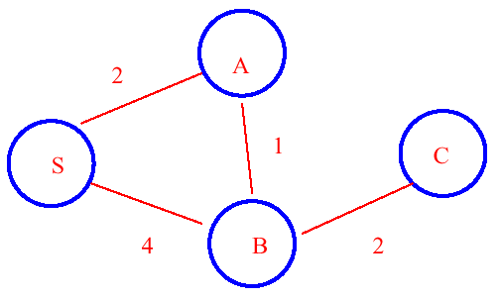
the binary path S-> B ->A is formed as follows:
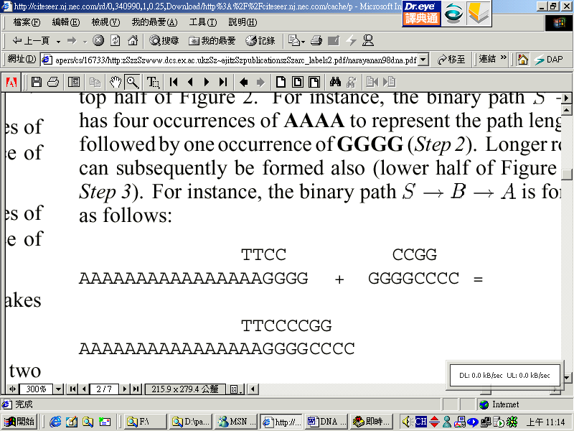
where the last tow bases of S->B and the first two bases of B->A are deleted because of the match.
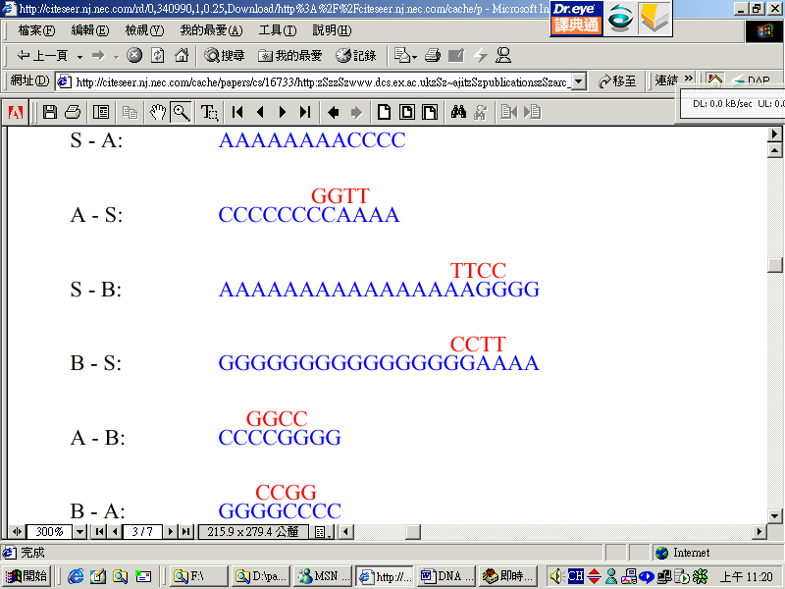
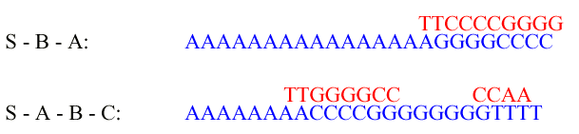
TSP DNA algorithm#2
- Sort the shortest path
- Create the following strands:
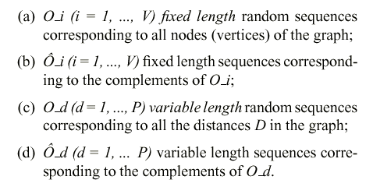
3、We create strands representing every binary path between two nodes in the graph.
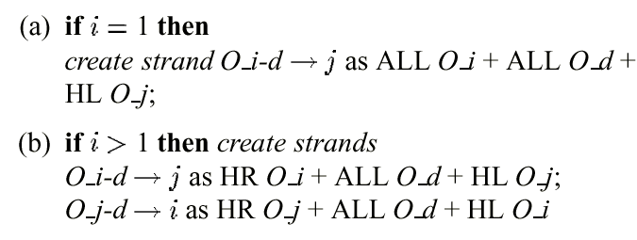
4、Insert into a test-tube all O_i-d->j and O_j-d->i followed by all Ô strands.
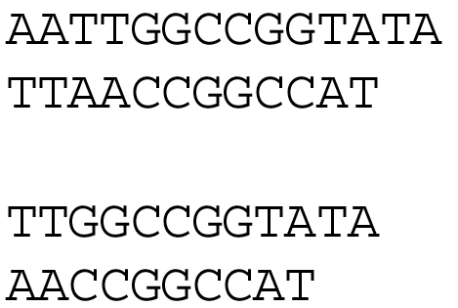
5、Only those strands which start the desired origin and terminate in the desired destination node are kept.

Created by : Hung-Yuan Wang
Date : Nov. 27, 2001

